**Edge Feed – RSS Feed widget**

**Manual Installation**

1. Copy **com.temenos.widgets.feed.RSS** folder in your widgets folder (Ex: /{your project/templates })
2. Restart IDE.

**Auto-Installation**

1. Run IDE.
2. Make sure the “**Switch Monitor on/off**” is checked.
3. Download/ Copy the widget (**com.temenos.widgets.feed.RSS.zip**) to monitored folder.

(**Tools** menu, **Options**, **Auto-install** tab and set in “**Download Location**” the folder where you copied the widgets.) No need to restart IDE.

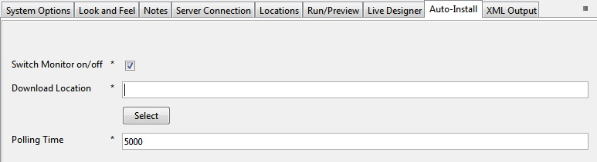

**Edge Feed – RSS Feed widget**

**Overview**

Edge Feed – RSS Feed is a widget for parsing and displaying RSS and Atom feeds. This widget uses Yahoo yql to retrieve feeds. You can obtain feeds easily from any domain. No need for server-side scripts.

1. You will have to insert a new display Item of **Edge Feed**  type in the **Presentation Editor**
2. Within **Widget Details**  tab you have to set up the widget settings.

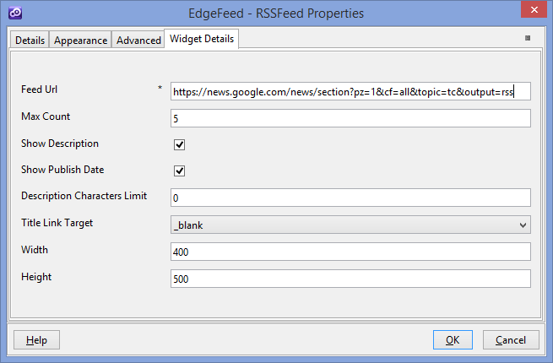

* **Feed Url** – The URL for the feed.
* **Max count** - The feed Items count that will be displayed within the widget.
* **Show Description** - Option to show the description of the feed Item
* **Show Publish Date -** Option to show the publish date of the feed Item
* **Description Characters Limit -** Feed Description Characters Limit Count . 0 mean no limit. How many characters from the feed item content will be displayed.
* **Title Link Target -** [The target attribute](http://www.w3schools.com/tags/att_a_target.asp) specifies where to open the linked document .
* **Width­** – The width of the feed container.
* **Height** – The height of the feed container.